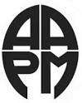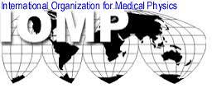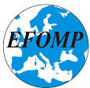

QA and Dosimetry of Emerging Radiotherapy Techniques
AAPM/IOMP Radiotherapy training course in Tallinn, Estonia (June 16-20, 2014)

American Association of Physicists in Medicine (AAMP), International Organisation for Medical Physics (IOMP), European Federation of Organisations in Medical Physics (EFOMP) together with North Estonia Medical Centre organised the training course in radiotherapy medical physics. The organising committee has planed diverse and stimulating scientific programme intended to show to practicing medical physicists and dosimetrists how to perform clinical tasks. Lectures, based on AAPM task group reports and publications, provide practical guidelines for implementation and Quality Control of new technology. The objective of the course is to show practical methods of work with modern technology in radiotherapy. After the course, the attendees should be able to modernize their practice in the light of the latest AAPM recommendations. There will be a practical session in a local radiotherapy department. The training course is mainly targeting Medical Physicists, Radiotherapy Technologists, and Dosimetrists; however, Radiation Oncologists may also benefit from it. For more information please visit the following web-site: http://www.regionaalhaigla.ee/?op=body&id=1023. Please, address all inquiries to the Local Organizer Eduard Gershkevitsh at eduardger@yahoo.co.uk.

Topics to be covered:
QC of linear accelerators as per AAPM TG 142
QA & QC of TPS and Record & Verify Systems
QC of Imaging equipment in Radiotherapy
Managing of imaging dose in IGRT
Small field dosimetry
Monte Carlo calculations
QC of IMRT/VMAT
QC of SRS/SBRT
Light ion beam technology developments and QC
Audits in radiotherapy
Licensing and certification of Medical Physicists

Eugene Lief (Course Director) Eduard Gershkevitsh (Local Organiser)


